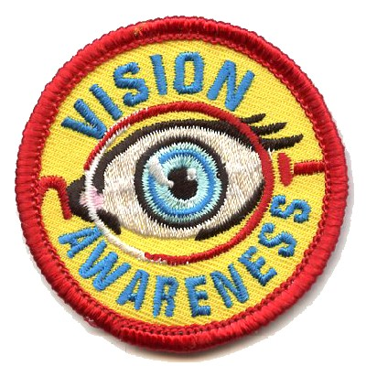

ATTENTION: ALL SCOUTS
Earn a Vision Awareness Patch while learning about your eyes and vision.

The activities required for this patch are fun, educational and you get to visit an eye doctor’s office.

This opportunity is brought to you by the
New York State Optometric Association.

For more information, please contact:
[contact information here]

Another suggestion for generating awareness of your participation is to add content to your website and social media channels, such as:
- Attention scout leaders! Find out how your troop can earn a free Vision Awareness Patch! Email us at [email@domain name].
- Did you know…your eyes are the size of ping pong balls? If you’re a scout, find out more about your eyes and how you see and earn a Vision Awareness Patch! For more info email us at [email@domain name].

