Dear Scouting Group Leaders and Parents/Caregivers,
As provider of comprehensive eye care in your community, I am pleased to inform you of the Vision Awareness Patch program, which offers a first-hand look at an optometrist’s office and includes several activities that are fun and educational for your scout(s) to enjoy.
Brought to you by the New York State Optometric Association, our goal for this program is to help your group understand the importance of sight, and how regular, comprehensive eye exams by a doctor of optometry can ensure detection, diagnosis, and prevention or treatment of eye conditions.
Vision is a miraculous and intricate process — something most of us take for granted. Eye problems and concerns should not be thought of as being limited to older people. About 25 percent of school-age children in the United States have vision problems, and it is estimated that more than 150,000 school children suffer eye injuries each year. If their eyes have problems or their vision is limited, their ability to participate in sports, learn in school, and observe the world around them may be significantly impaired and they can easily fall behind their peers. The more that young people know about how their eyes work and the regular care the eyes need, the more likely they will be to practice eye safety and preventive eye care throughout their lives.
The Vision Awareness Patch Program also offers an exposure to a career in the profession of optometry, encouraging the possible future study in science and technology.
Please refer to the following page for a list suggested activities for completion for your troop. For more information about eye health and vision care, visit www.nysoa.org.
If you are interested in scheduling a troop visit to our office to complete the patch activities, please contact us at:
Sincerely,
[Name and Title]

VISION AWARENESS PATCH PROGRAM
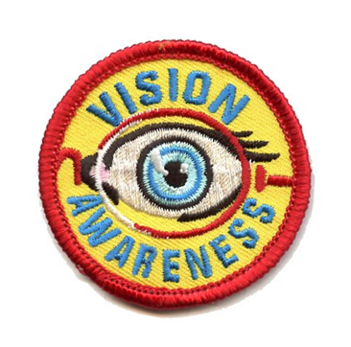
Suggested Activities For Your Troop
Visit a doctor of optometry’s office or have one come to your meeting. Locate an optometrist near you by visiting www.aoa.org/doctor-locator-search or calling the New York State Optometric Association at 518-449-7300.
Then, complete two activities below:
- Not everyone has 20/20 vision. Learn about nearsightedness, farsightedness and astigmatism and how glasses or contacts can help.

- Children often experience vision problems that are not easily detected. Learn how vision can affect school activities and how a doctor of optometry can help.

- The American Optometric Association’s National Save Your Vision Month is March. Make a poster for your school that promotes eye health and good vision practices.

- Learn about a career in optometry. What optometry schools are located in or near your state? How do you become licensed? What’s an average salary?

- Run an Eyeglass Donation Drive. Contact a local service organization that collects them. A suggestion is to visit https://lionsclubs.org/en/resources-for-members/resource-center/recycle-eyeglasses.

- Do “activities in the dark.” Divide the Scouts into pairs, having one scout put a blindfold on and the other be non-blindfolded. The blindfolded scout should try some basic activities such as buttoning or zipping a coat, tying shoes, writing, etc. The non-blindfolded scout should lead, explain what is seen and be a guide for safety purposes. Then trade roles. Discuss: How did it feel to not be able to see? How did you accomplish simple activities? What would you do if you met a blind person?
The American Optometric Association has activity sheets for younger children, as well as classroom exercises, on its website under “Resources for Teachers.” Other activities often of interest are optical illusions, making pinhole cameras, drawing and labeling parts of the eye, or demonstrating/observing how the pupil of the eye reacts in light and dark.

